H-DHAC: A Hybrid Clustering Protocol for Wireless Sensor Networks

Jiang Zhu, Chung-Horng Lung
Department of Systems and Computer Engineering
Carleton University, Ottawa, Canada
{jiangzhu, chlung}@sce.carleton.ca
Vineet Srivastava
Cistech Limited
Ottawa, Ontario, Canada
vineet@cistech.ca

Abstract—Clustering is one of the most energy-efficient methods to organize sensor nodes in Wireless Sensor Networks (WSNs). To perform clustering, location data are usually used for calculating the distance between sensor nodes. But location data may not always be available due to Global Positioning System (GPS) failures or may not be practical in consideration of cost. Alternatively, Received Signal Strength (RSS) or RSS Indicator (RSSI) is used as the distance estimator, but it has been showed that RSS or RSSI is unreliable in many studies. In order to mitigate these problems, we propose a hybrid clustering protocol — Hybrid Distributed Hierarchical Agglomerative Clustering (H-DHAC) — which uses both quantitative location data and binary qualitative connectivity data in clustering for WSNs. Our simulation results show that H-DHAC has a lower percentage of compromise in performance in terms of network life time and total transmitted data compared to similar approaches that use complete location data. However, H-DHAC still outperforms the well known clustering protocols, e.g., LEACH and LEACH-C.
Keywords—Wireless sensor networks, clustering protocol, hierarchical agglomerative clustering.

Introduction
In Wireless Sensor Networks (WSNs), sensor nodes are usually randomly deployed and operate in an unattended fashion in harsh environments. Since the energy of WSNs is limited in many applications, the major concern of WSNs has always been energy efficiency. Many clustering protocols have been proposed aiming to organize sensor nodes efficiently. However, in practice, many unexpected or uncontrollable difficulties may occur due to the complicated network environments, such as poor channel quality, sudden sensor node failures, etc. Most of the existing clustering protocols are based on an ideal case but fail to take some key issues into consideration, such as the reliability of Global Positioning System (GPS) or Received Signal Strength (RSS), and cost of GPS. The following passage elaborates this point more.
In WSNs, clustering is organizing sensor nodes in groups if they have high proximity. Usually, location data are used for calculating the distance between each sensor node. Studies which use location data for clustering assume that every sensor node is aware of its location or has GPS equipped. Although GPS is the most accurate and direct localization identification method, it faces a certain possibility of failure and the cost of a sensor node will be higher or significantly higher with GPS equipped (see Section II for more discussions). Alternatively, some studies adopt RSS or RSS Indicator (RSSI) to estimate the distance between sensor nodes, However, RSS and RSSI are not reliable distance estimators in practice which has been proven in many studies with experiments in real environments (also see Section II for more discussions).
978-1-4673-2480-9/13/$31.00 ©2013 IEEE
The Hierarchical Agglomerative Clustering (HAC) [1] algorithm is not a complicated but effective centralized clustering approach which has been successfully applied in many areas. DHAC [2] adapted HAC to WSNs as a distributed bottom-up hierarchical clustering protocol without having global knowledge or a centralized compute. This paper proposes a Hybrid Distributed Hierarchical Clustering (H-DHAC) protocol of which the fundamental mathematics model is based on HAC. H-DHAC further modifies the clustering approach of DHAC by extending it to support hybrid data (using both quantitative location data and qualitative connectivity data: simply 0s and 1s to indicate the absence or presence of connections). H-DHAC can operate even if location information is missing. Therefore, it not only provides a flexible design alternative for those who have a specific demand on cost or performance, but also supports reliable clustering by considering possible GPS failure(s) or missing GPS information.
The rest of this paper is organized as follows. Section II describes the background and challenges. Section III presents the proposed H-DHAC protocol. Section IV presents the simulation and results. Finally, Section V concludes the paper.

background and challenges of missing quantitative location data
Hierarchical clustering provides better adaptability and scalability in organizing sensor nodes, thus results in enhancements of resource efficiency and energy balancing for WSNs. Some representative clustering approaches are highlighted in the following. This section also discusses some practical problems with quantitative location data or missing location data. A brief discussion on GPS availability and RSS or RSSI reliability will be presented. Missing quantitative location data is also a crucial problem for many clustering algorithms. H-DHAC is a protocol that is specifically designed to consider the problems of GPS in terms of cost and possible missing location data.

Hierarchical Clustering Protocols
LEACH [3] is a well known distributed clustering protocol that balances the energy dissipation by giving each sensor node equal probability to become the Cluster Head (CH). CHs are randomly elected based on a probability function. After becoming CHs, they will broadcast advertisement messages to let other non-CH sensor nodes decide which cluster to join and become Cluster Members (CM) of a specific cluster according to measured RSS. The major drawbacks of LEACH are the randomness in clustering and periodic re-clustering.
LEACH-C [3] is the centralized version of LEACH in which a Base Station (BS) coordinates the clustering process. The BS is assumed to have location and residual energy data of every sensor node. Based on gathered data, the BS selects CHs and generates data gathering schedules, then broadcasts schedules back to sensor nodes. Since LEACH-C is a centralized approach, it provides better formation of clusters than LEACH in terms of energy balancing. However, centralized approach is not appropriate in many practical environments.
DHAC [2] is a novel distributed static clustering protocol that introduces a bottom-up approach into WSNs clustering. DHAC is inspired by the centralized HAC algorithm and adapts it to WSNs in a distributed manner. As a comprehensive clustering protocol, DHAC variations can use location data, RSS or connectivity data (0s and 1s) individually as input data set for clustering. The immobility characteristic of most WSNs is exploited by DHAC to avoid re-clustering, which results in higher energy efficiency. In simulation, DHAC shows better performance than LEACH and LEACH-C in various aspects.

RSS and RSSI Reliability as Distance Estimator
RSS and RSSI have been used frequently as a distance estimator in many studies that are related to localization and clustering in WSNs. However, these studies are mostly based on theoretical model and under the assumption that RSS and RSSI have low error rate or no error. In fact, this assumption is not realistic since wireless network environments are unstable and keep changing over time.
Lymberopoulos et al. [4] conducted a study on characterization of signal strength properties in 3D network environments. After several comprehensive experiments, they discovered the raw RSSI data can not indicate any distance information in most situations. Their conclusion is: direct distance prediction from raw RSSI data in 3D indoor environments is impossible.
Rong-Hou et al. [5] tried to find the characteristics and error patterns of RSSI through analyzing the variance of RSSI. Although they try to maintain a stable and unchanging environment, RSSI values still vary drastically. No pattern has been found in their experiments.
Heurtefeux et al. [6] conducted several comprehensive experiments using three different platforms with different topologies and materials. It is mentioned in their survey that three main factors, path-loss, fading and shadowing, affect signal strength [7], which causes the intrinsic limits of using RSSI for distance estimation. They tried to use Spring-Relaxation algorithm in their experiments to smooth the errors of RSSI, but it did not work. In their conclusion, RSSI is determined as an inferior candidate to estimate distance.

GPS Availability and Vulnerability
The cost a GPS chip can range from $5 [8] to a few thousand [9]. On the other hand, the price of a wireless sensor ranges from about $1 [10] to a few thousand [11]. Thus, the cost of a sensor could be doubled or significantly higher if it is equipped with GPS.
Moreover, GPS faces a certain possibility of failure and is also possible to report imprecise location because of interference [12]. The reason is that the satellite signal is weak at the receiver’s end [13], it can be easily interfered and the receiver could possibly miss the satellite signal or be misled by other signals.
Bhatti et al. [14] classified potential failure modes of GPS and summed up 23 different reasons of GPS failures. Some of the effects can be significant, such as a jamming signal which pretends to be a GPS satellite signal intentionally to cause GPS malfunction. Unintentional interferences can also possibly happen when some devices (e.g., VHF) generates signals with frequency similar to a satellite. In addition, there is a tradeoff between reliability and cost, i.e., cheaper GPS receivers have higher possibility of failure.

Challenges of Missing Location Data for Clustering
If a sensor node does not have location data obtained from GPS for whatever reason, the effect on clustering is more than just one missing data item. When using location data for clustering, the distances between sensor nodes need to be calculated. One missing location data item of a sensor node will result in unavailability of distance calculation between that specific sensor node and other sensor nodes. As a result, it is impossible for some algorithms to find the closest neighbor without complete distance information. Hence, it is difficult to use incomplete location data for clustering. The degree of difficulty increases with higher number of missing location data. In order to use hybrid location and connectivity data for clustering, the challenges caused by missing location data need to be resolved. H-DHAC is a protocol that is specifically designed for this problem.

Hybrid Distributed Hierarchical Clustering Protocol
H-DHAC protocol is based on the LEACH communication model [3]. The main contribution of H-DHAC is the feature to handle scenarios where location data may be unavailable. H-DHAC operates in a distributed manner and can use two different kinds of data for clustering: quantitative location data and qualitative connectivity data (0s and 1s). Quantitative location data are preferred if available; otherwise, qualitative connectivity data (binary data indicating if two nodes are connected) are used by sensor nodes which do not have complete location data.
To minimize the effect of errors and randomness of incorrect or missing location information, H-DHAC introduces two novel control parameters: confidence level (CL) and C_{MIN} (minimum number of quantitative coefficients for coefficient estimation). In H-DHAC, the clustering process is designed in favor of the location data which have higher accuracy than the connectivity data.

Clustering
This section presents the clustering process of H-DHAC. The fundamental mathematical concept is based on well-known HAC [1] algorithms. H-DHAC further modifies and extends this process to enable distributed hybrid clustering.

Step 1: Exchange Local Information
In the beginning of clustering, a sensor node has no knowledge of other nodes because they are deployed randomly. Thus each sensor node will broadcast a HELLO message to inform its 1-hop neighbors. This HELLO message includes its ID, GPS availability status (Yes or No), location (if available). Meanwhile, if a sensor node receives a HELLO message from another node, it will store the information for further use.
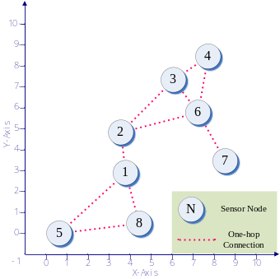
- A 8-node network topology
After exchanging HELLO messages, sensor nodes are aware of their neighbors and are able to establish their own neighbor lists. Then a sensor node will exchange its own neighbor list with its neighbors in the same manner as exchanging HELLO messages. Fig. 1 shows an example of an 8-node network with 1-hop connection relationship between each sensor node.

Step 2: Build Local Resemblance Matrix
This step is to compute a matrix of resemblance coefficients. A resemblance coefficient for a pair of sensor nodes represents the degree of similarity or dissimilarity between these two sensor nodes, depending on the coefficient. The distance dissimilarity coefficients can be calculated by Pythagorean Theorem based on quantitative location data. The Sorenson method [1] is adopted to calculate similarity coefficients from qualitative connectivity data.
Initially, each sensor node forms a singleton cluster and becomes the cluster head (CH). Take node 1 in Fig.1 as an example, its resemblance matrix is shown in Table I. This local resemblance matrix has both quantitative and qualitative coefficients and its quantitative coefficients are complete, because none of the location data is missing.
- Initial local resemblance matrix of A node
Cluster {1}
Neighbor  Cluster | Coefficient
Neighbor  Cluster | Quantitative | Qualitative
{2} | 1.94 | 0.5
{5} | 4.27 | 0.143
{8} | 2.51 | 0.143

Step 3: Generate Clusters
Cluster formation in H-DHAC includes several iterations, and this process will finish when the desired number of clusters is reached and cluster size satisfies the preconfigured value.
The following describes the steps for cluster formation of one round:
- Each CH finds its closest neighbor using the best coefficient available, (quantitative coefficients are preferred, but qualitative coefficients will be used if quantitative coefficients are not complete).
- The CH with a smaller ID sends an INVITATION message to its closest neighbor.
- In the case where a CH does not have complete quantitative coefficients but its closest neighbor does, the CH with larger ID will be the one that sends the INVITATION message.
- Invitations will be rejected if it is not from the closest neighbor cluster. If a CH receives REJECTION message, it will stop making invitation attempt for this round.
- In the case where invitation sender has complete quantitative coefficients while the invitation receiver does not (this situation will be referred as “CONFIDENCE invitation” from now on), receiver will keep sender’s information (including sender’s confidence level (CL)).
- An invitation receiver will reply with CONFIRMATION message if the Invitation is from its closest neighbor.
- If a CH receives “CONFIDENCE invitation” and did not receive INVITATION or REJECTION message from its closest neighbor, the CH will confirm with the “CONFIDENCE invitation” sender if the “CONFIDENCE invitation” sender satisfies the CL threshold (e.g., 70%); otherwise it will be rejected.
- If there is more than one eligible “CONFIDENCE invitation” sender, the one with the highest CL is chosen.
- If any confirmation has been made, two clusters which are the CONFIRMATION message sender and receiver will be merged into a new cluster, and an INFORM message will be broadcasted to the new cluster’s neighbors to update their resemblance matrices.
Confidence level is defined by:
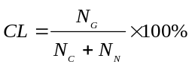
In equation (1), N_{C} is the total number of sensor nodes of its own cluster; N_{N} is the total number of sensor nodes of all other neighbor clusters; N_{G} is the number of sensor nodes which have location data available in N_{C} and N_{N}. CL is used for determining the percentage of location data available sensor node of a certain cluster. In other words, higher CL means better accuracy of coefficient estimation (see subsection B for more discussions), which results in higher credibility of “CONFIDENCE invitation”. By introducing the control parameter CL into clustering, the error of merging clusters can be mitigated and controlled.
A new round of cluster formation will start if the desired number of clusters (e.g., 5) has not reached. Otherwise, cluster size control will be performed. If a cluster’s size does not meet the minimum threshold (e.g., 10 sensor nodes), this cluster will be merged with its closest neighbor cluster. After completing cluster size control, cluster formation process is finished. Similar to DHAC [2] and some static clustering methods, re-clustering is no longer needed beyond this point to save energy. The termination conditions are based on the assumption that the communications among sensors are operational, which has also been adopted by other similar papers.

Handling with Missing Coefficients
When there are some changes in neighbors’ information (e.g. a cluster is newly formed), resemblance matrix of that cluster should be updated. There are four commonly used methods: Single LINKage method (SLINK), Complete Linkage method (CLINK), Unweighted Pair-Group Method with arithmetic Averages (UPGMA) and Weighted Pair-Group Method with arithmetic Averages (WPGMA) [1]. Updating resemblance matrices with qualitative coefficients is the same as HAC since qualitative data are always available. However, special handling is needed for blanks in quantitative coefficient matrix caused by missing location data.
An example of using UPGMA method to update resemblance coefficients in H-DHAC is presented in this section.
- Update resemblance matrix of cluster {3,6} using UPGMA
(a) BEFORE UPDATE (b) AFTER UPDATE (C_{MIN} = 2)
Cluster {3,6} |  |  |  | Cluster {3,6}
Neighbor  Cluster | Coefficient |  |  | Neighbor  Cluster | Coefficient
Neighbor  Cluster | Quantitative | Qualitative |  | Neighbor  Cluster | Quantitative | Qualitative
{2} | — | 0.2915 |  | {4} | — | 0.1965
{4} | — | 0.1965 |  | {7} | — | 0.548
{7} | — | 0.548 |  | {1,2} | 4.14  —* | 0.52775
 |  |  |  | *When C_{MIN} = 3
TABLE II shows an example of updating resemblance matrix of cluster {3, 6} using UPGMA. Assume that node-3’s location data are missing, i.e., no quantitative coefficient is available initially in this matrix as shown in TABLE II (a). Now assume that a new cluster formed by merging clusters {1} and {2} so that coefficients for clusters {1, 2} and {3, 6} need to be updated. The quantitative coefficient D_{{3, 6}{1, 2}} can be estimated as follow (D_{{1, 6}} = 4.49 and D_{{2, 6}} = 3.79 are available but not shown in Table II):
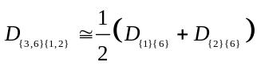
The result of equation (2) (D_{{3, 6}{1, 2}} ≌ 4.14) fills one blank in the matrix which is one step further towards complete resemblance matrix. However, D_{{3, 6}{1, 2}} cannot be estimated if the control parameter C_{MIN} is set to be 3. As previously mentioned, C_{MIN} is the minimum number of coefficients required in two merging clusters for coefficient estimation.
By introducing the control parameter C_{MIN} into clustering, the precision of coefficient estimation can be improved.

Scheduling and Data Gathering Stage
This step is similar to DHAC [2]. After the clustering process is complete, sensor nodes start to collect and gather data. In H-DHAC, data gathering is operated in a hierarchical manner. There are two phases in each round of data gathering: intra-cluster transmission phase and CH to BS transmission phase. CHs take charge of data collection scheduling and transmit gathered data to BS.
To balance the energy consumption of each sensor node in a cluster, automatic CH rotation is performed at the end of each round. When the residual energy of a CH is lower than a threshold or there are some changes to a cluster (e.g. a sensor node joins, leaves or dies), a rescheduling process will be operated to achieve better energy efficiency.

Simulation and results
The simulations of several WSNs clustering protocols are run on NS-2. Network topologies are randomly generated, each topology contains 100 sensor nodes. The simulation is tested on 10 different topologies. In TABLE III, the summarized simulation parameters and their values are presented.
- simulation parameters
Parameter | Value
Sensor Node Number | 100
Field Size | 300×300 m²
Channel Bandwidth | 2 Mbps
Radio Electronic Energy Dissipation Rate | 50 nJ/bit
Radio Amplifier Energy Dissipation Rate (Є_{fs}, Є_{mp}) | 5 pJ/bit/m2  0.00065 pJ/bit/m4
Cross-over distance (d_{crossover}) | 87 m
Initial Energy | 1 J/node
Data Fusion Energy Dissipation Rate | 5 nJ/bit
Data Gathering Rate | 5 TDMA frames per 10 sec
Data Packet Size | 500 Bytes
As a well-known clustering protocol, LEACH is a good reference since many other studies have also been compared with LEACH. The following highlights the energy model that is derived from LEACH [3] for our simulation.
- Transmitting Energy Dissipation
Whether the Friss space model (Є_{friss-amp} and d²) or two-ray ground propagation model (Є_{two-ray-amp} and d⁴) is chosen depends on cross over distance d_{crossover}. E_{elec} is the energy consumption of transmitting or receiving one bit of data. The energy consumption model for a sensor node to transmit any type of data is defined by the following equation:
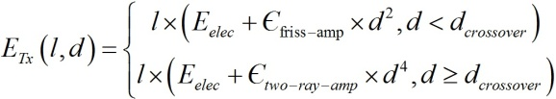
- Receiving Energy Dissipation
To receive l bit data, the energy is consumed by:
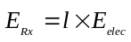
- Data Fusion and Computational Energy Dissipation
E_{fusion} is the energy consumption of processing one bit of data. The energy consumption of data fusion and computation of resemblance matrix update is calculated by:
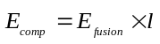
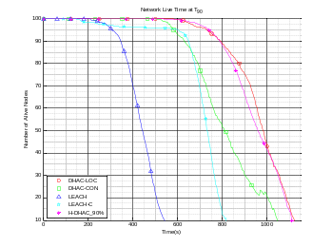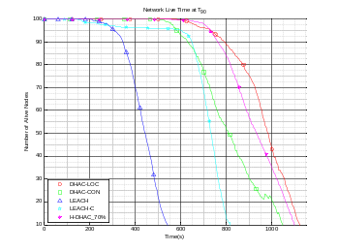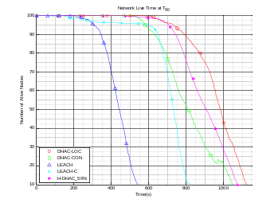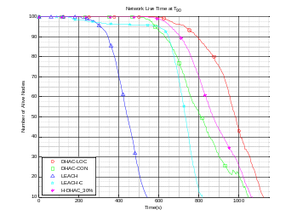
(a) H-DHAC_90% (b) H-DHAC_70% (c) H-DHAC_50% (d) H-DHAC_30%
- Network lifetime at T₉₀ with BS at (150,300)
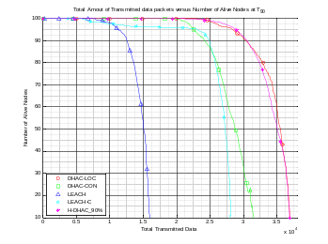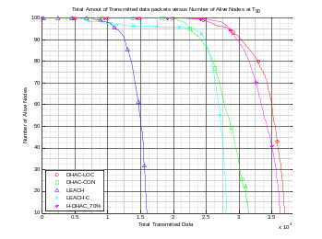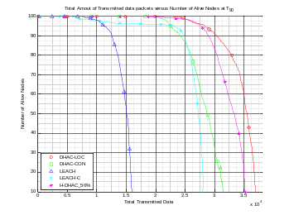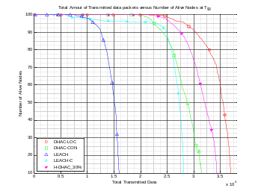
(a) H-DHAC_90% (b) H-DHAC_70% (c) H-DHAC_50% (d) H-DHAC_30%
- Total amount of transmitted data at T₉₀ with BS at (150,300)

The performance of each protocol is measured by network lifetime and total transmitted data. These metrics are evaluated for LEACH, LEACH-C, DHAC-LOC (location), DHAC-CON (connectivity) and H-DHAC with 4 different percentages of location data availability (90%, 70%, 50% and 30%).
The simulation results of LEACH, LEACH-C, DHAC-LOC and DHAC-CON are based on the average performance on 10 topologies. For H-DHAC, another scenario needs to be considered: the sensor nodes without location data are randomly selected in order to be more practical. Therefore, there will be more simulation runs to be performed for the random node scenario. In our experiments, 10 runs of simulation on each of the topologies were performed to minimize the influence of randomness. Hence the simulation results of H-DHAC are based on the average performance of 100 runs for each percentage of location data availability (i.e. there are totally 400 runs of simulation for H-DHAC alone) which represents a broad coverage of experiments.
The results show that H-DHAC works with any percentage of location data availability (0%–100%), it performs similar to DHAC-LOC in its best case scenario (100%) and performs similar to DHAC-CON when no location data available (0%). In theory, the performance of H-DHAC cannot surpass DHAC-LOC and will be always better than DHAC-CON if availability > 0%. In the following of this section, T_{n%} is used to represent the time when n% of sensor nodes are dead.

Network Lifetime
Fig. 2 shows the network lifetime of H-DHAC compared to different protocols. H-DHAC_xx% denotes H-DHAC with xx% of location data available. Since a WSN with less than 10% of sensor nodes functioning basically cannot provide any useful data, the end point of network life time is set to be T₉₀.
It’s very clear that H-DHAC_90% has almost the same T₉₀ as that of DHAC-LOC, there is only 0.45% difference. Further, H-DHAC_90% prolongs T₉₀ by 105.84% from LEACH, 37.02% from LEACH-C, 9.18% from DHAC-CON. While H-DHAC_30%, the lowest parameter prolongs T₉₀ by 94.82% from LEACH, 29.68% from LEACH-C, 3.33% from DHAC-CON and is less than DHAC-LOC by 6.14%.
The differences of lifetime between H-DHAC with different parameters at T₉₀ are small. H-DHAC_50% extends by 1.09% from H-DHAC_30%. H-DHAC_70% has 2.86% longer lifetime than H-DHAC_50% while H-DHAC_90% prolongs by 1.61% from H-DHAC_70%. The improvement of H-DHAC is larger with higher percentage of location data available in terms of network lifetime.

Total Amount of Transmitted Data
The results of the total amount of transmitted data in packets are shown in Fig. 3. More data transmitted to the BS means sensor nodes are doing better job in providing interested data. H-DHAC_90% transmitted 36906 packets at T₉₀ which is 20948 packets (131.27%) more than LEACH, 8711 packets (30.90%) higher than that of LEACH-C, 5731 packets (18.38%) over DHAC-CON and only 31 packets (0.08%) less than DHAC-LOC. H-DHAC_30% transmitted 34288 packets at T₉₀. That is 3113 packets (9.99%) more than DHAC-CON, 6093 packets (21.61%) higher than LEACH-C, 18330 packets (114.86%) over LEACH.
When it comes to data gathering efficiency at T₉₀, H-DHAC_50% transmitted 35213 packets which is 2.70% higher than that of H-DHAC_30%; H-DHAC_70% transmitted 36230 packets which is 2.89% over H-DHAC_50%; H-DHAC_90% transmitted 36906 packets which is 1.87% more than that H-DHAC_70%. Similar to the situation in network lifetime, higher location data availability percentage results in better improvement in terms of total amount of transmitted data.

Lifetime/Price Ratio
- lifetime/price ratio at t₆₀
Lifetime (%) | Price (%) | Lifetime/Price
95.855 | 90 | 1.065
92.746 | 70 | 1.325
89.637 | 50 | 1.793

As stated in Section II, the cost of GPS is also an important factor to consider for some WSNs. The price range for sensor nodes is wide. This paper proposes another evaluation metric – lifetime/price ratio – for WSNs. The metric can be used to evaluate the tradeoff between average lifetime of sensor nodes and the cost of GPS. For simplicity, we assume that the cost of GPS component dominates compared to other parts of a sensor node. This would present the extreme case from the cost perspective as an illustration.
TABLE IV demonstrates a simple example of lifetime/price ratio at T₆₀ (the results of T₆₀ were obtained from simulation). This ratio can be used to compare cost benefit with respect to equipping 100% of GPS for the sensor nodes. In TABLE IV, H-DHAC with different GPS availability values (90%, 70%, and 50%) are compared to the case where 100% GPS is available. The first column represents the lifetime ratio at T₆₀ if 90%, 70%, or 50% of the nodes have GPS compared to 100% of the nodes that have GPS, respectively. Similarly, the second column is the cost ratio if only 90%, 70%, or 50% of the nodes have GPS compared to 100% of the nodes that have GPS, respectively.
As shown in this simple scenario, the lifetime/price ratio becomes larger with lower ratio on GPS. In other words, the network lifetime degrades slowly while the cost saving increases at a higher rate. For instance, the lifetime only decreases about 3% if the GPS availability value decreases from 90% to 70%. However, the lifetime/price ratio increases close to 30% at the same time. The gap is even larger from 90% to 50%, i.e., ~6% lower for lifetime but ~73% potential reduction for lifetime/price ratio under the assumption that the cost of GPS component contributes the most for a sensor node. Thus, H-DHAC has a great potential of saving cost for high GPS cost while remain competitive on performance at the same time. This characteristic was not seen in any other protocol. As such we propose that this be considered for future studies.

Conclusions and Future Work
This paper presented a hybrid clustering approach for WSNs. This paper extended the traditional hierarchical clustering approach to accommodate two different kinds of data at the same time, i.e., quantitative location data and qualitative connective data (simply 0s and 1 representing connections). H-DHAC is capable of dealing with any percentage of location data availability and is robust enough to reduce the influence of randomness by using two novel control parameters, CL and C_{MIN}, for clustering to meet the challenges of missing location data.
The simulation results showed that H-DHAC outperforms LEACH, LEACH-C and DHAC-CON (using connectivity binary data only) in all scenarios and with small compromise compared to DHAC-LOC (using location information). H-DHAC does not require every sensor node to have location data and does not depend on RSS or RSSI to estimate distance. Hence, H-DHAC is an approach that is suitable for practical scenarios to reduce the cost and increase the reliability of a WSN.
Multi-hop communication mechanisms have been adopted by some researchers for WSNs. One of the future directions is to extend those multi-hop methods that use only the location or RSS/RSSI information for clustering by using our hybrid approach. Another direction is to investigate the effect of asymmetrical communications between sensors. In other words, node A can receive a message from node B, but node B does not have the connectivity with node A.

References
- C. Romesburg, Cluster analysis for researchers, 2004.
- C. H. Lung and C. Zhou, "Using hierarchical agglomerative clustering in wireless sensor networks: An energy-efficient and flexible approach," Ad Hoc Networks, vol. 8, pp. 328-344, 2010.
- W. B. Heinzelman, et al., "An application-specific protocol architecture for wireless microsensor networks," IEEE Trans on Wireless Communications, vol. 1, pp. 660-670, 2002.
- D. Lymberopoulos, et al., "An Empirical Characterization of Radio Signal Strength Variability in 3-D IEEE 802.15.4 Networks Using Monopole Antennas Wireless Sensor Networks," Proc. of EWSN, pp. 326-341, 2006.
- W. Rong-Hou, et al., "Study of characteristics of RSSI signal," Proc. of IEEE Int’l Conf. on Industrial Tech, pp. 1-3, 2008.
- K. Heurtefeux and F. Valois, "Is RSSI a Good Choice for Localization in Wireless Sensor Network?," Proc. of IEEE 26th Int’l Conf on AINA , pp. 732-739, 2012.
- H. Hashemi, "The indoor radio propagation channel," Proceedings of the IEEE, vol. 81, pp. 943-968, 1993.
- L. Privat. (2007, March 29th). TI announced new GPS chip, cost under $5. Available: http://www.gpsbusinessnews.com/TI-announced-new-GPS-chip-cost-under-5_a102.html
- E. Gakstatter. (2010, June 1st). The Dawn of a New ERA in GPS Accuracy. Available: http://www.gpsworld.com/gis/gss-weekly/the-dawn-a-new-era-gps-accuracy-10016
- I. F. Akyildiz, et al., "A survey on sensor networks," Communications Magazine, IEEE, vol. 40, pp. 102-114, 2002.
- M. P. Frank, et al., "Design of a wireless sensor network with nanosecond time resolution for mapping of high-energy cosmic ray shower events," Proc. of SPIE Defense, Security, and Sensing Symposium, p. 2, 2010.
- A. Dempster, "How Vulnerable is GPS?," Position, vol. 20, pp. 64-67, 2005.
- D. Hoey and P. Benshoof, "Civil GPS Systems and Potential Vulnerabilities," Proc. of ION GNSS 18th Int’l Technical Meeting of the Satellite Division, pp. 1291 - 1295, 2005.
- U. I. Bhatti and W. Y. Ochieng, "Failure Modes and Models for Integrated GPS/INS Systems," The Journal of Navigation, vol. 60, pp. 327-348, 2007.

